Report about best devices in PC, best operating system and suitable programming languages.
System Name:
- Best Devices
The best device for this desktop app is personal computer with at least processor core i5 with 265GB SSD and 8 Ram

- Best Operating System
The best operating system is Windows 10 and windows 11 because it offers many features like Visual Studio And support SQL DBMS and Microsoft office

- Suitable Programming Languages
The best programming language for any desktop app is C# with .Net , sql server to manage my data and tables easily and store important data and make a CRUD operations easily.

- Suitable Applications

WPF C#

Design of an integrated system (Class diagram)

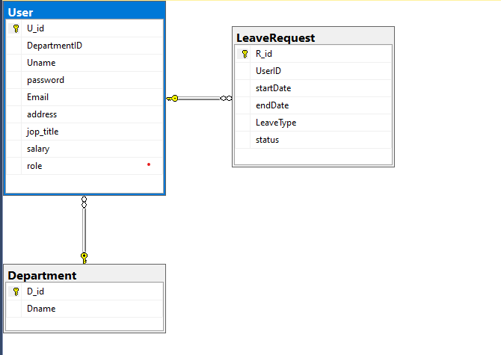

Testing
Test case ID | Test case description | Test Steps | Test Data | Expected Result | Actual Result | Pass/Fail
1 | User enters valid name and password | User enters his name  User enters his password | Name:  Admin  Pass:  1 | Login successfully | Login successfully | pass
2 | User enters valid name and invalid password | User enters his name  User enters his password | Name:  Admin  Pass:  0*7 | Error Message | Error Message | Pass
3 | User enters invalid name and valid password | User enters his name  User enters his password | Name:  Ad  Pass:  1 | Error message | Login successfully | fail
4 | User enters invalid name and invalid password | User enters his name  User enters his password | Name:  An  Pass:  0*7 | Error message | Error message | pass
5 | User takes name box empty and enter valid password | User enters his name  User enters his password | Name:  Pass:  1 | Error message | Login successfully | fail
6 | User takes password box empty and enter valid name | User enters his name  User enters his password | Name:  Pass:

